First Passive Acoustic Monitoring Strategic Initiative Workshop Report

La Jolla, California

Matti Meikäläinen

Ashok Kumar

3/1/24

Table of contents

# Citation

PAM-SI Meeting Repository

# 1. Introduction to Meeting Attendees

### 1.0.1 [Insert Image] Name, *Institution* (using Header 3)

Write ~ 3 sentences about yourself (the work you do, what you do for fun). Bonus if you’d like to cite a favorite publication (yours or others).

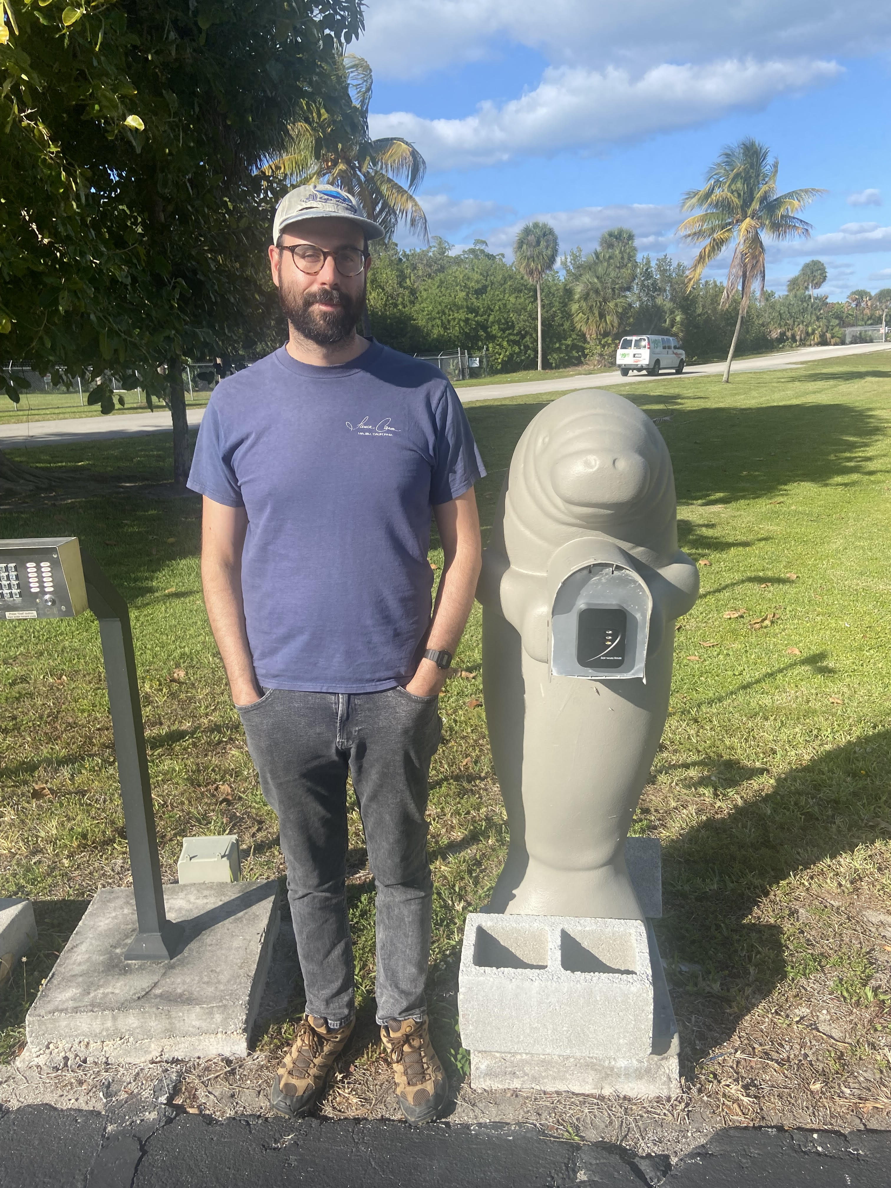

### 1.0.2 Ludovic (Ludo) Tenorio-Hallé, [*SEFSC*](https://www.fisheries.noaa.gov/about/southeast-fisheries-science-center) */* [*CIMAS*](https://cimas.earth.miami.edu)

Ludo is a postdoctoral associate with University of Miami’s Cooperative Institute for Marine and Atmospheric Studies (CIMAS) working with NOAA Southeast Fisheries Science Center. He is currently involved in various PAM projects in the southeast region, including passive acoustic localization and tracking of Rice’s whales and quantifying the impacts of seismic airguns surveys in the Gulf of Mexico. All his work so far has been done in MATLAB, but he has never used R before. Ludo also just moved back to San Diego after spending a couple of years in Miami.

## 1.1

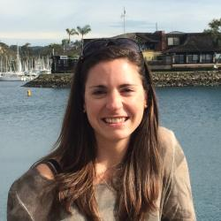

### 1.1.1 Genevieve Davis, [*NEFSC*](https://www.fisheries.noaa.gov/new-england-mid-atlantic/endangered-species-conservation/passive-acoustic-research-atlantic-ocean)

Genevieve is a research biologist in the Passive Acoustics Branch at NEFSC in Woods Hole, MA. She started there as a NOAA Hollings scholar in 2010, and now leads the baleen whale passive acoustic projects.

### 1.1.2

### 1.1.3 Marla Holt, [*NWFSC*](https://www.fisheries.noaa.gov/west-coast/science-data/southern-resident-killer-whale-noise-and-disturbance-research)

Marla Holt is a Research Wildlife Biologist for the NWFSC Marine Mammal Ecology Team in Seattle, WA. Her current research focuses on the effects of noise on sound use and behavior of endangered killer whales. When not working, she enjoys skiing, dancing and attending various events with her sports enthusiastic family.

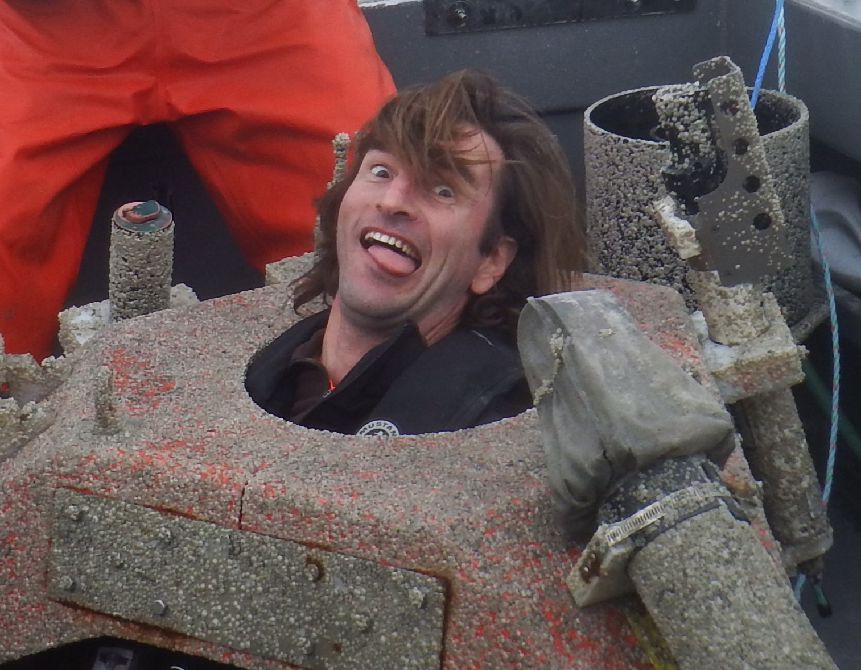

### 1.1.4 Manolo Castellote, [*AFSC*](https://www.fisheries.noaa.gov/about/marine-mammal-laboratory) *&* [*CICOES*](https://cicoes.uw.edu/)

Manolo is a U. of Washington employee working for MML/AFSC through the cooperative institute CICOES. He started at MML as a postdoc in 2010 to apply acoustics to Cook Inlet Beluga (CIB) to expand knowledge on seasonal distribution and effects of noise, but soon got involved in other PAM projects for MML, often in collaboration with Catherine Berchok’s group. He continues do do beluga PAM in Cook Inlet and other regions of AK, but is also involved in work on other species in topics including hearing, behavioral response, noise mitigation, noise regulation, and soundscape characterization.

### 1.1.5

### 1.1.6 Cory Hom-Weaver, [*SWFSC*](https://www.fisheries.noaa.gov/west-coast/science-data/southwest-acoustic-ecology-lab)

Cory started working as an acoustic ecologist at SWFSC in 2020. During her time at the center, her research has focused the detection and classification of baleen whales in the California Current Ecosystem. She is also interested in technological development of passive acoustic monitoring systems. In her free time she loves to surf, cook and hike.

### 1.1.7

### 1.1.8 **Becca Van Hoeck*,*** [NEFSC](https://www.fisheries.noaa.gov/new-england-mid-atlantic/endangered-species-conservation/passive-acoustic-research-atlantic-ocean)

Becca coordinates the Inflation Reduction Act funding the NEFSC Passive Acoustic Branch received for the PAM Strategic Initiative and North Atlantic right whale monitoring. She also conducts research and participates in regional coordination related to offshore wind energy development focused on fish and soundscapes. Outside of work, she spends her time reading fiction, spending time outside, and wrangling her two year old son.

### 1.1.9

### 1.1.10 **Megan McKenna*,*** [CIRES-NCEI](https://www.ncei.noaa.gov/products/passive-acoustic-data)

Megan works with collaborative teams collecting PAM data, currently with the SoundCoop and previously with SanctSound. Megan helps to unravel these complex data by applying analytical tools- both new and existing- into standardized data processing pathways. While interested in metrics that look at the whole soundscape, vessel noise is often a focus. Megan also teaches graduate classes on marine science and policy at Middlebury Institute of International Studies in Monterey. When not working, Megan is out exploring the beautiful central coast of California with her family.

### 1.1.11

### 1.1.12 **Shannon Rankin*,*** [***SWFSC***](https://www.fisheries.noaa.gov/west-coast/science-data/southwest-acoustic-ecology-lab)

Shannon leads the Southwest Acoustic Ecology Lab at SWFSC in La Jolla. She has worked with a variety of marine mammals (from vaquita to blue whales, and most everything in between) using mobile PAM platforms: towed arrays, sonobuoys, drifting buoys, and this year she’ll begin to work with gliders.

### 1.1.13

### 1.1.14 Annamaria DeAngelis, [*NEFSC*](https://www.fisheries.noaa.gov/contact/annamaria-deangelis-mres)

Annamaria works in the NEFSC’s Passive Acoustics Branch as the odontocete team lead and IT liaison. She has a passion for beaked whales, and loves to go out in the field to catch a glimpse (acoustically or visually) of them. Unsurprisingly, a very influential paper to her career was Peter Tyack’s [Extreme diving of beaked whales](https://journals.biologists.com/jeb/article/209/21/4238/16329/Extreme-diving-of-beaked-whales), as it provided one of the first looks into this elusive genus of whales. She has two young children that keep her busy outside of work.

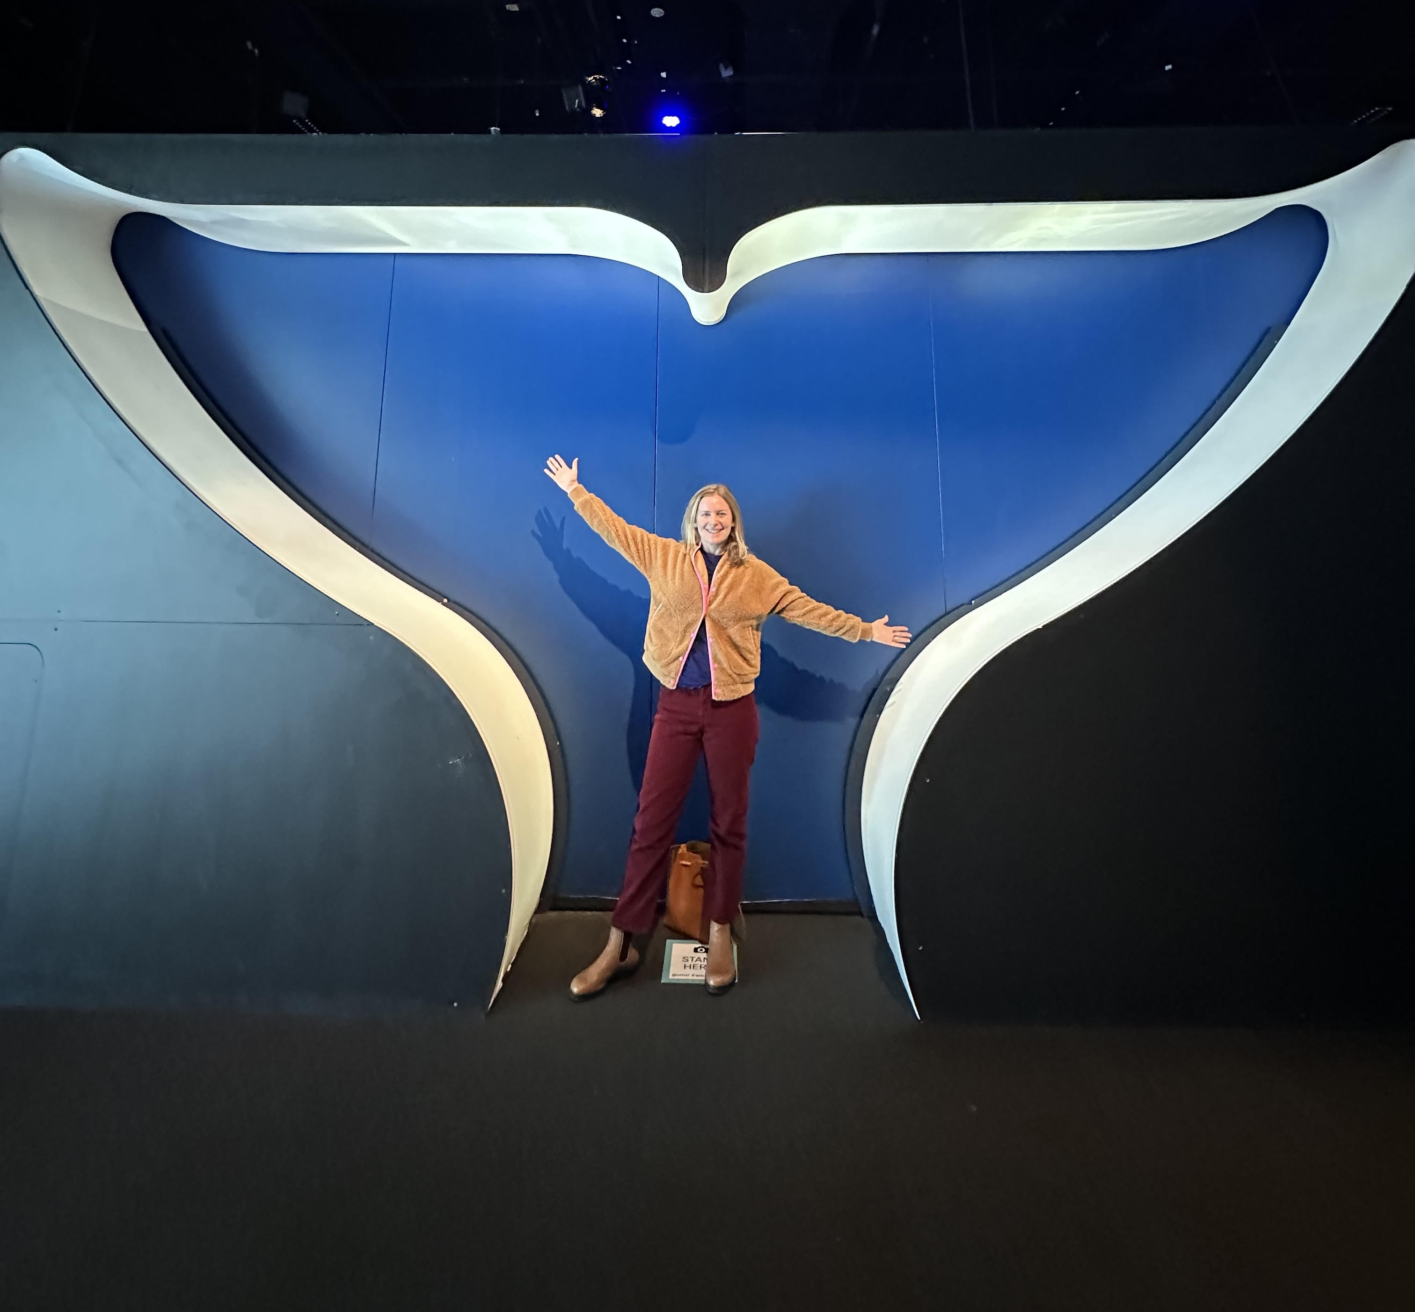

### 1.1.15 Samara Haver, [CIMERS](https://www.pmel.noaa.gov/people/dr-samara-haver)

Samara is a research associate in the Oregon State University/NOAA PMEL Cooperative Institute for Marine Ecosystems and Resources Studies. Samara’s research primarily focuses on marine soundscapes and ocean noise, and she collaborates closely with NOAA NMFS, ONMS, and the National Park Service to monitor and understand underwater sound in U.S. waters.

### 1.1.16

### 1.1.17 Kourtney Burger, [*SWFSC*](https://www.fisheries.noaa.gov/west-coast/science-data/southwest-acoustic-ecology-lab)

Kourtney started working with the Southwest Acoustic Ecology lab as a lab technician in 2022. She assists the team with data management and archive, data analysis, an general lab management and maintenance. Outside of work, she enjoys reading, spending time outside, and hanging out with her dog and family.

### 1.1.18

### 1.1.19 Candice Emmons, [*NWFSC*](https://www.fisheries.noaa.gov/about/northwest-fisheries-science-center)

Candice is a Research Wildlife Biologist for the NWFSC Marine Mammal Ecology Team in Seattle, WA. She works on variety of projects including winter habitat use and foraging ecology of Southern resident killer whales. Her research has been focused on using PAM to better understand killer whale movements outside the Salish Sea.

### 1.1.20

### 1.1.21 Carrie Wall, [*CIRES-NCEI*](https://www.ncei.noaa.gov/products/passive-acoustic-data)

Carrie is a research scientist for the University of Colorado Boulder Cooperative Institute for Research in Environment Sciences / NOAA National Centers for Environmental Information in Boulder, CO. She leads the Ocean Acoustic Archives at NCEI encompassing 100s TB of water column sonar and passive acoustic data and leads several projects focused on building community tools and services to process data faster, more efficiently, and comparably. She’s also been known to dabble in AI, most recently in making ridiculous pictures.

### 1.1.22

### 1.1.23 Taiki Sakai [*SWFSC* / *NEFSC*](https://www.fisheries.noaa.gov/contact/taiki-sakai)

Taiki has been working at the Southwest Fisheries Science Center since 2016, but will transition to the Northeast Fisheries Science Center in April. He loves beaked whales because they are adorable weirdos, but his work unfortunately mostly involves programming instead of hanging out with them. He has built a wide variety of PAM-related tools with the main focus of trying to simplify and streamline various PAM tasks for researchers in his group.

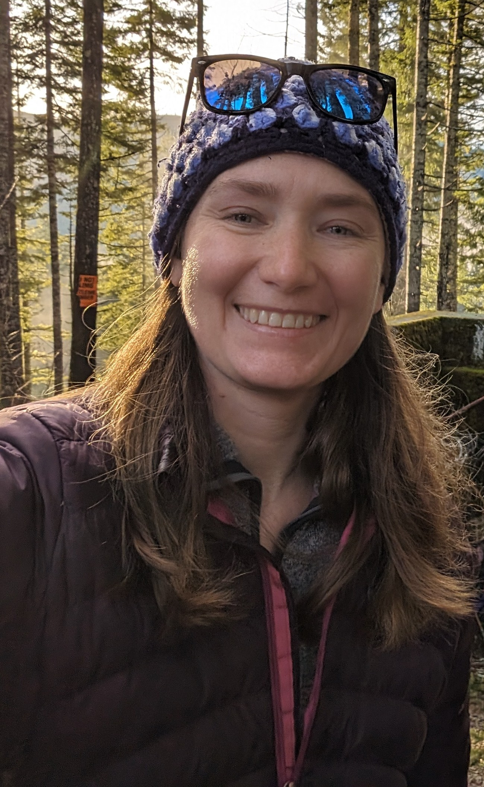

### 1.1.24 Ann Allen [*PIFSC*](https://www.fisheries.noaa.gov/about/pacific-islands-fisheries-science-center)

Ann is a Research Oceanographer with the Cetacean Research Program at PIFSC in Hawaii. She primarily manages the Pacific Islands Passive Acoustic Network, made up of HARP recordings collected at locations around the Pacific Islands, dating back to 2005 and currently totalling about 1.6M hours of recording. She has dabbled in cloud and AI to aid in analyzing the large dataset. In 2023, she transitioned to working remotely from Washington state.

### 1.1.25

### 1.1.26 Daniel Woodrich [*AFSC*](https://mail.google.com/mail/u/0/?to=daniel.woodrich@noaa.gov&su=Dan%20burning%20Question&body=Dan%20I%20Have%20A%20Question:%20&fs=1&tf=cm)

Dan is a researcher and member of the IT office at the AFSC. He applies/develops AI/ML software to help streamline the work of the marine mammal passive acoustics group, and he provides a range of AI and cloud support across the science center through the IT role.

### 1.1.27

### 1.1.28 Yvonne Barkley [*CIMAR*](https://www.soest.hawaii.edu/cimar/)- [*PIFSC*](https://www.fisheries.noaa.gov/about/pacific-islands-fisheries-science-center)

Yvonne is a Cetacean Acoustics Research with the Cooperative Institute for Marine and Atmospheric Research in support of the Cetacean Research Program at PIFSC. She works on several PAM projects, including acoustic classification models, spatial data analyses that integrate different data streams, and acoustic tracking/localization. On her down time, Yvonne enjoys not staring at a screen and can be found biking, surfing, or hiking.

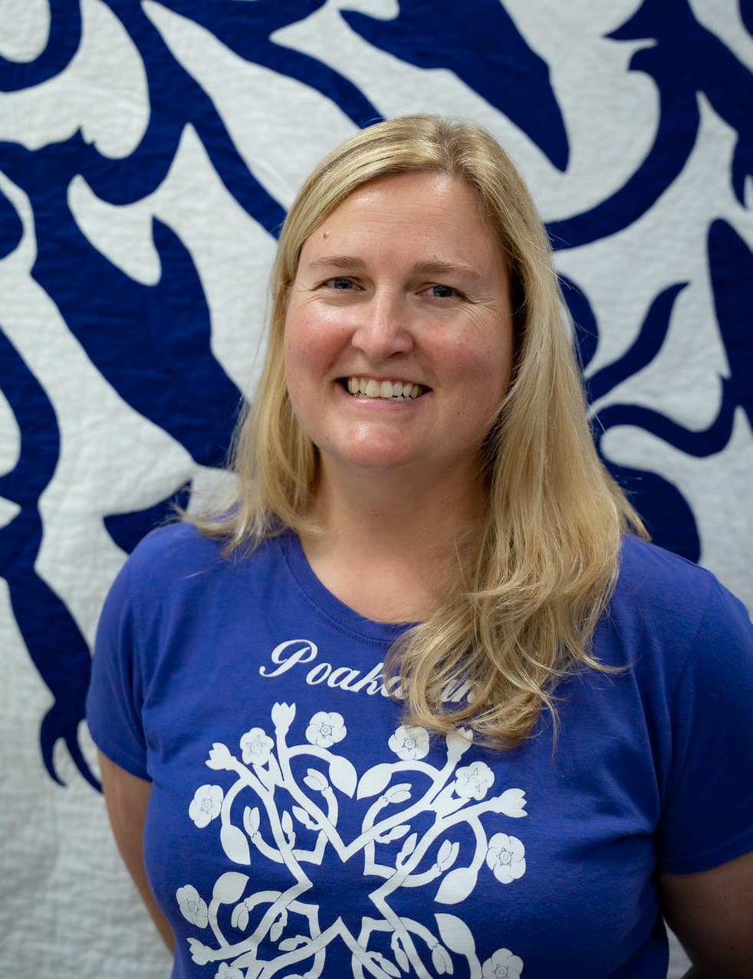

### 1.1.29 Jennifer McCullough [*PIFSC*](https://www.fisheries.noaa.gov/about/pacific-islands-fisheries-science-center)

Jennifer is a Research Biologist in the Cetacean Research Program at the Pacific Islands Fisheries Science Center. She has worked in the field of acoustics for over 20 years focusing on various marine mammals, bears, and birds. Current work focuses on acoustic detection and classification of false killer whales and various species of beaked whales.

# References